**BOILER EFFICIENCY**

The efficiency of the boiler can be computed by indirect method testing which is measuring the losses occurring in the boiler. The efficiency can be arrived at, by subtracting the heat loss fractions from 100. These losses include loss due to dry flue gas (sensible heat), loss due to hydrogen in fuel (H2), loss due to moisture in fuel (H2O), loss due to moisture in air (H2O), loss due to carbon monoxide (CO), and loss due to surface radiation, convection and other unaccounted.

1. Chimney Loss

For thermal power plants, the typical flue gas temperature is equal to 160 °C and the ambient temperature of chosen location is 28 °C.

a. Dry Flue Gas Loss

b. Moisture Loss

c. Humidity Loss

2. Unburnt Loss

3. Radiation Loss

Radiation Loss is assumed to contribute 1% at maximum.

4. Unaccountable Loss

Unaccountable loss was assumed to contribute 10% of the boiler losses.

Adding up all the losses:

Solving for the boiler efficiency:

**COAL ANALYSIS**

**Ultimate Analysis of Sub-Bituminous Coal**

|  |  |  |  |  |  |  |
| --- | --- | --- | --- | --- | --- | --- |
|  | Sample 1 | Sample 2 | Sample 3 | Sample 4 | Sample 5 | Average |
| Hydrogen | 4.67 | 4.2 | 4.19 | 4.42 | 4.11 | 4.318 |
| Carbon | 58.35 | 55.68 | 57.85 | 56.23 | 54.67 | 56.556 |
| Nitrogen | 1.09 | 1.02 | 1.03 | 1.04 | 1.01 | 1.038 |
| Sulfur | 0.78 | 0.75 | 0.76 | 0.74 | 0.73 | 0.752 |
| Oxygen | 16.36 | 16.34 | 16.48 | 16.42 | 16.08 | 16.336 |
| Ash | 19.86 | 18.53 | 23.01 | 19.1 | 24.5 | 21 |

The higher heating value considering the boiler efficiency:

Pulverized coal fired boilers run with an average of 20% excess air in order to burn the fuel completely:

The ambient temperature for the municipality of Lian is 28 °C. Calculating for the humidity of air:

The actual air fuel ratio with consideration to excess air requirements and humidity of air in the chosen location is as follows:

**Design Option 1**

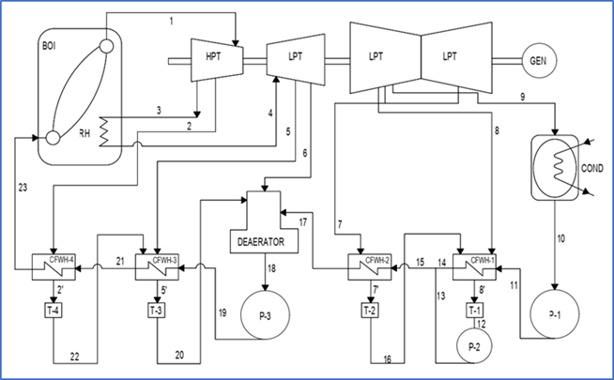

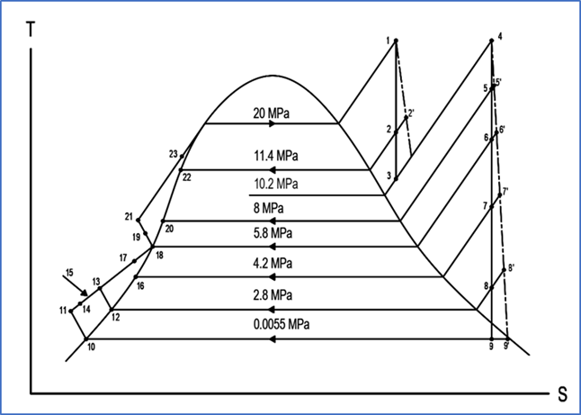

**STATE POINT CALCULATIONS**

|  |  |  |  |  |
| --- | --- | --- | --- | --- |
| **State Point** | **Pressure (Mpa)** | **Temp. (°C)** | **Enthalpy (kJ/kg)** | **Masssteam (kg/s)** |
| 1 | 20 | 540 | 3363.5 | 664.9221 |
| 2 | 11.4 | 441.0918 | 3192.366 | 51.3755 |
| 3 | 10.2 | 422.9157 | 3160.955 | 613.5467 |
| 4 | 10.2 | 540.0000 | 3473.7 | 613.5467 |
| 5 | 8 | 496.9753 | 3390.769 | 21.0832 |
| 6 | 5.8 | 442.9586 | 3287.589 | 24.6361 |
| 7 | 4.2 | 392.0950 | 3191.107 | 25.1051 |
| 8 | 2.8 | 332.8021 | 3079.313 | 146.6369 |
| 9 | 0.0055 | 34.5800 | 2057.615 | 396.0854 |
| 10 | 0.0055 | 34.5800 | 144.95 | 396.0854 |
| 11 | 2.8 | 34.6686 | 147.7607 | 396.0854 |
| 12 | 2.8 | 226.1694 | 972.2296 | 171.7420 |
| 13 | 4.2 | 226.1716 | 972.2397 | 171.7420 |
| 14 | 4.2 | 226.1716 | 972.2397 | 396.0854 |
| 15 | 4.2 | 226.1716 | 972.2397 | 567.8274 |
| 16 | 4.2 | 249 | 1080.486 | 25.1051 |
| 17 | 5.8 | 246.7 | 1069.404 | 567.8274 |
| 18 | 5.8 | 268.7692 | 1178.298 | 664.9221 |
| 19 | 8 | 273.1920 | 1197.801 | 664.9221 |
| 20 | 8 | 290.0380 | 1289.262 | 72.4586 |
| 21 | 11.4 | 287.7380 | 1276.908 | 664.9221 |
| 22 | 11.4 | 315.3939 | 1433.344 | 51.3755 |
| 23 | 20 | 313.0939 | 1419.563 | 664.9221 |

For the calculation of actual pressure:

From PPE by Morse, p.228, sec. 8-5. The allowable pressure drop is 5% to 7 %, the equation is then:

Pactual = Pgiven – Pgiven (0.07)

For the calculation of actual enthalpy:

From the catalog of steam turbine, assuming the isentropic efficiency is 49%, the equation is then:

|  |  |  |  |
| --- | --- | --- | --- |
| **State Point** | **Actual Pressure (Mpa)** | **Actual Temperature (°C)** | **Actual Enthalpy (kJ/kg)** |
| 2 | 10.602 | 315.3939 | 3279.6444 |
| 5 | 7.44 | 290.038 | 3433.0635 |
| 6 | 5.394 | 268.7692 | 3361.7812 |
| 7 | 3.906 | 249 | 3278.1508 |
| 8 | 2.604 | 226.176 | 3180.7202 |
| 9 | 0.0051 | 32.974 | 2630.3984 |

**MASS BALANCE**

Mass balance for extracted steams in the turbines:

For CFWH4:

For CFWH3:

For Deaerator:

Where:

m1 = m22 = 0.0773m

m20 = m22 + m2

m20 = 0.0773m + 0.0317m = 0.1089m

For CFWH2:

Where:

m15 = m17

m17 = m – m1 – m2 – m5

m15 = m17 = 0.8539m

For CFWH1:

For Condenser:

**SOLVING FOR MASS OF STEAM (kg/s) ASSUMING A CAPACITY OUTPUT OF 500 MW:**

**SOLVING FOR INDIVIDUAL WORK OF TURBINES:**

Heat added in the Boiler, QB

Heat added in Reheater. QRH

Total Heat Added, QA

Turbine Work, WT

Pump Work, WP

Net Cycle Work, Wnet

Thermal Efficiency, eth

**DESIGN OPTION 2**

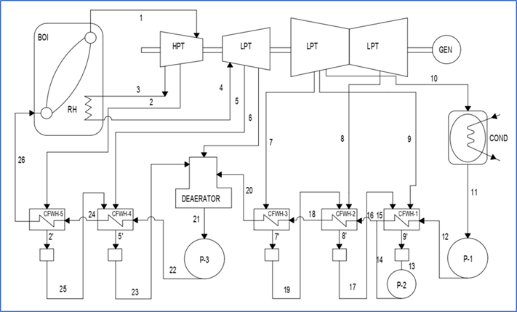

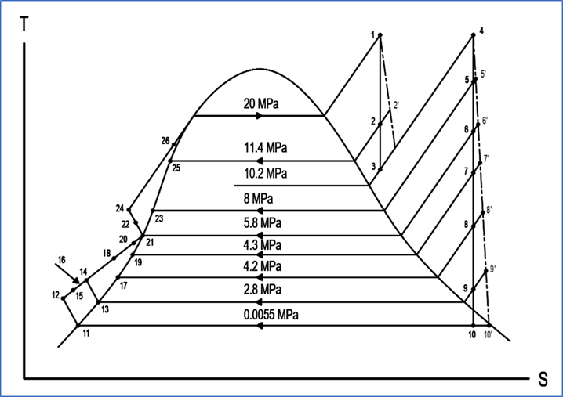

**STATE POINT CALCULATIONS**

|  |  |  |  |  |
| --- | --- | --- | --- | --- |
| **State Point** | **Pressure (Mpa)** | **Temp. (°C)** | **Enthalpy (kJ/kg)** | **Masssteam (kg/s)** |
| 1 | 20 | 540 | 3363.5 | 654.5760 |
| 2 | 11.4 | 441.0918 | 3192.366 | 50.5761 |
| 3 | 10.2 | 422.9157 | 3160.955 | 603.9999 |
| 4 | 10.2 | 540 | 3473.7 | 603.9999 |
| 5 | 8 | 496.9753 | 3390.769 | 20.9173 |
| 6 | 5.8 | 442.9586 | 3287.589 | 22.6021 |
| 7 | 4.3 | 395.6944 | 3197.924 | 1.7082 |
| 8 | 4.2 | 392.095 | 3191.107 | 25.2454 |
| 9 | 2.8 | 332.8021 | 3079.313 | 145.0702 |
| 10 | 0.0055 | 34.58 | 2057.615 | 388.4567 |
| 11 | 0.0055 | 34.58 | 144.95 | 388.4567 |
| 12 | 2.8 | 34.6686 | 147.7607 | 388.4567 |
| 13 | 2.8 | 226.1694 | 972.2296 | 172.0238 |
| 14 | 4.2 | 226.1716 | 972.2396 | 172.0238 |
| 15 | 4.2 | 226.1716 | 972.2396 | 388.4567 |
| 16 | 4.2 | 226.1716 | 972.2396 | 560.4805 |
| 17 | 4.2 | 249 | 1080.486 | 26.9536 |
| 18 | 4.3 | 246.7 | 1069.404 | 560.4805 |
| 19 | 4.3 | 250.3852 | 1087.237 | 1.7082 |
| 20 | 5.8 | 248.0852 | 1076.092 | 560.4805 |
| 21 | 5.8 | 268.7692 | 1178.298 | 654.5760 |
| 22 | 8 | 273.192 | 1197.269 | 654.5760 |
| 23 | 8 | 290.038 | 1289.262 | 71.4934 |
| 24 | 11.4 | 287.738 | 1276.9083 | 654.5760 |
| 25 | 11.4 | 315.3907 | 1433.3444 | 50.5761 |
| 26 | 20 | 313.0939 | 1419.5634 | 654.5760 |

For the calculation of actual pressure:

From PPE by Morse, p.228, sec. 8-5. The allowable pressure drop is 5% to 7 %, the equation is then:

Pactual = Pgiven – Pgiven (0.07)

For the calculation of actual enthalpy:

From the catalog of steam turbine, assuming the isentropic efficiency is 49%, the equation is then:

|  |  |  |  |
| --- | --- | --- | --- |
| **State Point** | **Actual Pressure (MPa)** | **Actual Temperature (°C)** | **Actual Enthalpy (kJ/kg)** |
| 2 | 10.602 | 315.3939 | 3279.6444 |
| 5 | 7.44 | 290.038 | 3433.0635 |
| 6 | 5.394 | 268.7692 | 3361.7812 |
| 7 | 3.999 | 250.3852 | 3281.4909 |
| 8 | 3.906 | 249 | 3237.2028 |
| 9 | 2.604 | 226.176 | 3159.8367 |
| 10 | 0.0051 | 32.974 | 2619.7479 |

**MASS BALANCE**

Mass balance for extracted steams in the turbines:

For CFWH5:

For CFWH4:

For Deaerator:

For CFWH3:

For CFWH2:

For CFWH1:

For Condenser:

**SOLVING FOR MASS OF STEAM (kg/s) ASSUMING A CAPACITY OUTPUT OF 500 MW:**

**SOLVING FOR INDIVIDUAL WORK OF TURBINES:**

Heat added in the Boiler, QB

Heat added in Reheater. QRH

Total Heat Added, QA

Turbine Work, WT

Pump Work, WP

Net Cycle Work, Wnet

Thermal Efficiency, eth

**DESIGN OPTION 3**

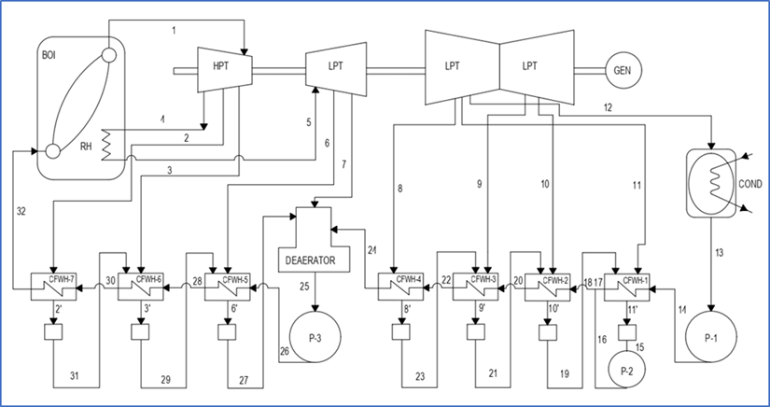

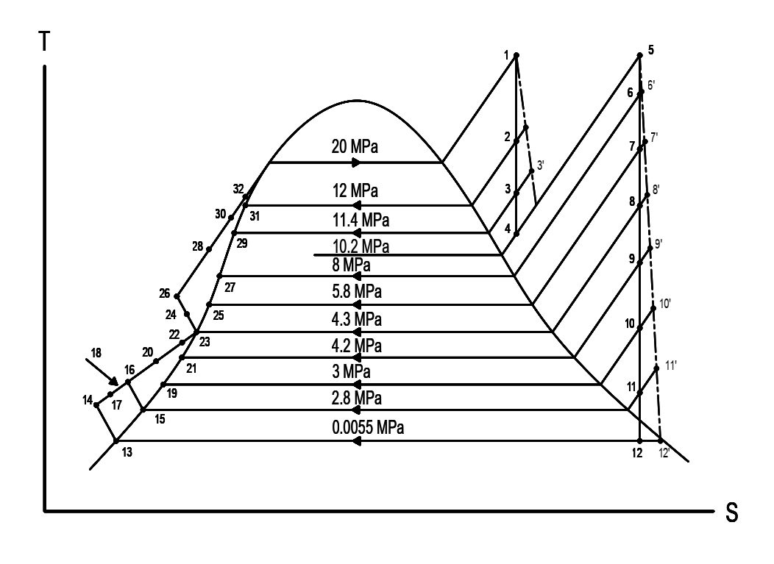

**STATE POINT CALCULATIONS**

|  |  |  |  |  |
| --- | --- | --- | --- | --- |
| **State Point** | **Pressure (Mpa)** | **Temp. (°C)** | **Enthalpy (kJ/kg)** | **Masssteam (kg/s)** |
| 1 | 20 | 540 | 3363.5 | 644.9323 |
| 2 | 12 | 449.6117 | 3207.0544 | 8.5151 |
| 3 | 11.4 | 441.0918 | 3192.3663 | 50.7987 |
| 4 | 10.2 | 422.9157 | 3160.9554 | 585.6184 |
| 5 | 10.2 | 540 | 3473.7000 | 585.6184 |
| 6 | 8 | 496.9753 | 3390.7685 | 20.7713 |
| 7 | 5.8 | 442.9586 | 3287.5893 | 21.3696 |
| 8 | 4.3 | 395.6944 | 3197.9236 | 1.6564 |
| 9 | 4.2 | 392.0950 | 3191.1070 | 21.8150 |
| 10 | 3 | 342.5326 | 3097.6024 | 3.1396 |
| 11 | 2.8 | 332.8021 | 3079.3129 | 141.6325 |
| 12 | 0.0055 | 34.5800 | 2057.6146 | 375.2340 |
| 13 | 0.0055 | 34.5800 | 144.9500 | 375.2340 |
| 14 | 2.8 | 34.6686 | 147.7607 | 375.2340 |
| 15 | 2.8 | 226.1694 | 972.2296 | 168.2435 |
| 16 | 3 | 226.1716 | 972.2396 | 168.2435 |
| 17 | 3 | 226.1716 | 972.2396 | 375.2340 |
| 18 | 3 | 226.1716 | 972.2396 | 543.4775 |
| 19 | 3 | 229.9020 | 989.6650 | 26.6110 |
| 20 | 4.2 | 229.9020 | 978.9053 | 543.4775 |
| 21 | 4.2 | 249 | 1080.4856 | 23.4713 |
| 22 | 4.3 | 246.7 | 1069.4040 | 543.4775 |
| 23 | 4.3 | 250.3852 | 1087.2374 | 1.6564 |
| 24 | 5.8 | 248.0852 | 1076.0915 | 543.4775 |
| 25 | 5.8 | 268.7692 | 1178.2976 | 21.3696 |
| 26 | 8 | 272.5420 | 1194.6118 | 644.9323 |
| 27 | 8 | 290.0380 | 1289.2620 | 80.0851 |
| 28 | 11.4 | 287.7380 | 1276.9083 | 644.9323 |
| 29 | 11.4 | 315.3939 | 1433.3444 | 59.3138 |
| 30 | 12 | 313.0939 | 1419.5634 | 644.9323 |
| 31 | 12 | 319.2300 | 1456.7400 | 8.5151 |
| 32 | 20 | 316.9300 | 1442.6730 | 644.9323 |

For the calculation of actual pressure:

From PPE by Morse, p.228, sec. 8-5. The allowable pressure drop is 5% to 7 %, the equation is then:

Pactual = Pgiven – Pgiven (0.07)

For the calculation of actual enthalpy:

From the catalog of steam turbine, assuming the isentropic efficiency is 49%, the equation is then:

|  |  |  |  |
| --- | --- | --- | --- |
| **State Point** | **Actual Pressure (MPa)** | **Actual Temperature (°C)** | **Actual Enthalpy (kJ/kg)** |
| 2 | 11.16 | 319.23 | 3286.8416 |
| 3 | 10.602 | 315.3939 | 3240.5487 |
| 6 | 7.44 | 290.038 | 3433.0635 |
| 7 | 5.394 | 268.7692 | 3361.7812 |
| 8 | 3.999 | 250.3852 | 3281.4909 |
| 9 | 3.906 | 249 | 3237.2028 |
| 10 | 2.79 | 229.902 | 3168.7986 |
| 11 | 2.604 | 226.1716 | 3124.9505 |
| 12 | 0.0051 | 32.974 | 2601.9559 |

**MASS BALANCE**

Mass balance for the extracted steams:

For CFWH7:

For CFWH6:

For CFWH5:

For CFWH4:

For Deaerator:

For CFWH3:

For CFWH2:

For CFWH1:

**SOLVING FOR MASS OF STEAM (kg/s) ASSUMING A CAPACITY OUTPUT OF 500 MW:**

**SOLVING FOR INDIVIDUAL WORK OF TURBINES:**

Heat added in the Boiler, QB

Heat added in Reheater. QRH

Total Heat Added, QA

Turbine Work, WT

Pump Work, WP

Net Cycle Work, Wnet

Thermal Efficiency, eth

**FUEL CONSUMPTION AND ENVIRONMENTAL PARAMETERS**

**Fuel Consumption**

**For Design Option 1:**

**Environmental Parameters**

Carbon oxides emission, *COx*

Nitrogen oxides emission, *NOx*

Sulfur oxides emission, *SOx*

Ash Disposal

**For Design Option 2:**

**Environmental Parameters**

Carbon oxides emission, *COx*

Nitrogen oxides emission, *NOx*

Sulfur oxides emission, *SOx*

Ash Disposal

**For Design Option 3:**

**Environmental Parameters**

Carbon oxides emission, *COx*

Nitrogen oxides emission, *NOx*

Sulfur oxides emission, *SOx*

Ash Disposal

**COMPUTATION FOR OTHER COMPONENTS**

**Coal Storage Facility**

For 1 month storage of coal:

The coal storage facility has an area of ______.

To determine the height of the storage area:

The height of the coal storage area was approximately __.

**Chimney**

Solving for mass of air:

For the mass of flue gas:

Assume exit temperature = 150 °C, Mfg = 30.7

For chimney diameter:

Average allowable exit velocity = 7.5 m/s.

For chimney pressure drop:

Chimney height = 275 m

Air density at 28 °C, humidity is 77%, Pressure at 101.3 kPa, ρo = 1.171 kg/m3

**Cooling Water Requirement**

@ Nasugbu Bay, water temperature (T1) = 30 °C

@ Statepoint 12: h = 2057.6146 kJ/kg; @ Statepoint 13: h = 144.95 kJ/kg

Pump flowrate = 50 m3/s up to 50.4722 m3/s

Density of water at 30 °C = 995.67 kg/m3

*DENR permits a temperature increase of 3 °C for waste water disposal, therefore waste water should be cooled by 2.9314176 °C before exit.*